OMUKENKUFU NYANZI JULIUS

Chief Executive Officer, Prof Bioresearch

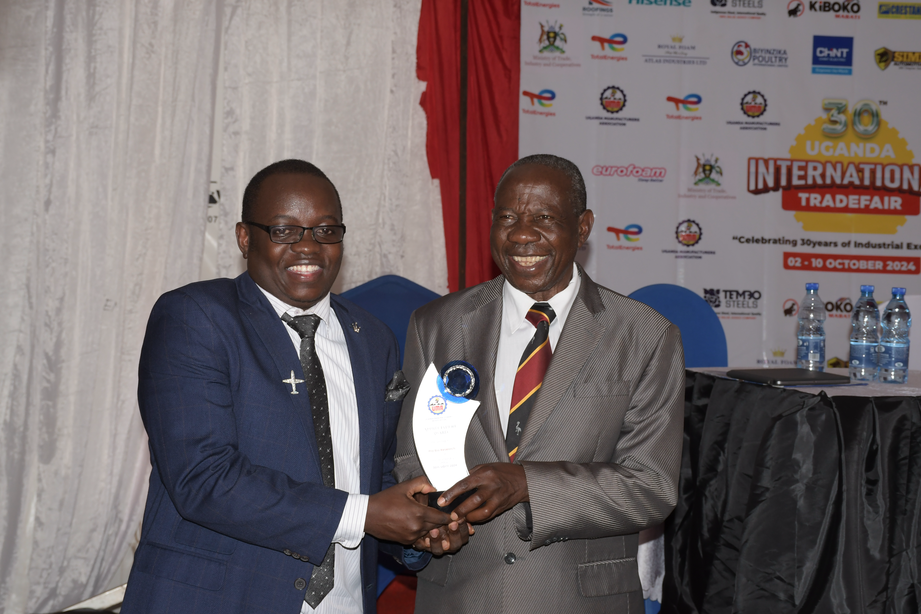
Hon. Matia Kasaija presenting the 50th career Award to Omukenkufu Nyanzi Julius at the UMA Trade Fair 2024

PROFESSIONAL PROFILE

Omukenkufu Nyanzi Julius is a Ugandan bio-entrepreneur, scientist, researcher, and innovator with more than 10 years of experience in bioresearch, natural product development, and complementary & alternative medicine (CAM). He holds a Bachelor of Science (Botany & Chemistry) and a Master of Science in Pharmacognosy (Drug Research & Development) from Makerere University.

Before graduating in 2014, he served as a bioresearch consultant for leading research institutions including AgroGenetic Research Laboratories ,East Africa’s largest tissue culture facility and Kawanda Research Laboratories, Uganda’s plant improvement center. His work included designing advanced propagation protocols for disease-free stevia and mushrooms.

Motivated by the need for practical scientific solutions that uplift African communities, he founded Prof Bioresearch, a trailblazing natural products and bioresearch company based in Kampala. Over the last decade, he has led a team of young scientists in transforming Uganda’s natural resources into high-quality oils, powders, herbal supplements, and aromatherapy products produced with modern extractive technologies and international-standard processes.

His innovations have been widely recognized nationally and internationally, helping build public confidence in Uganda’s herbal medicine sector. Several of his products—including stevia,Amatugunda sugar and natural mosquito repellents—have become household names, driving scientific appreciation of locally sourced natural therapies.

KEY ACHIEVEMENTS & AWARDS
• Kampala Innovator of the Year – Kampala City Council Authority (2012)
• Innovator of the Year – Private Sector Foundation Uganda (2016)
• Most Innovative Youth – Pakasa Awards (2017)
• Best Manufacturer of the Year – Uganda Manufacturers Association(2018)
• Innovator of the Year – Uganda Manufacturers Association (2019)
• Medical Personnel of the Year – Uganda Workers Union (2020)
• Best Pathogen Scientist – Uganda (2021)
• East African Community Innovator of the Year (2022)
• East African Community Bioresearcher of the Year (2023)
• Trendsetter of the Year (2024)
• East African Community Scientist of the Year (2025)
• Career Achievement Award – UMA 50th Anniversary (2024)

RECENT APPOINTMENT

In 2025, he was appointed by Hon. Dr. Monica Musenero as an SME Policy Advisor to the Uganda National Council of Science and Technology and the Science, Technology & Innovation Secretariat, in recognition of his contribution to research, innovation, and national development.

CORE COMPETENCIES
• Natural product research & development
• Pharmacognosy & plant-based drug discovery
• Tissue culture & micro-propagation
• Bio-entrepreneurship & commercial innovation
• Herbal extraction technologies
• Public health product innovation
• Strategic leadership & scientific advisory
• Community-based wealth and health solutions

MISSION

In all his work, Nyanzi strives to use scientific knowledge and indigenous resources to create wealth, improve health, and inspire a generation of African innovators.

FAMOUS QUOTES

1.“ EKYUMA KIWAGALA KYUMA – IRON SHARPENS IRON”

2. “ MONEY GROWS ON TREES – SSENTE ZIMERA KU MITI”

